FORUM REQUESTS SECTION BUGS & FLOW FIX

BUGS:

1. In the “Forum Request Offer” section, offers should be displaying in chronological order with the most recent offer to be displayed on the top of the page.
2. In the “Forum Request Offer” section, we need to add a “Search bar” to enable user to search for an offer based on the keyword input.
3. Change “Requests” title to “Product Requests” and remove Drop-down. When clicking “Product Requests” users should be directed directly to view all Product Requests list page (the page currently called “Forum Request Offer”).

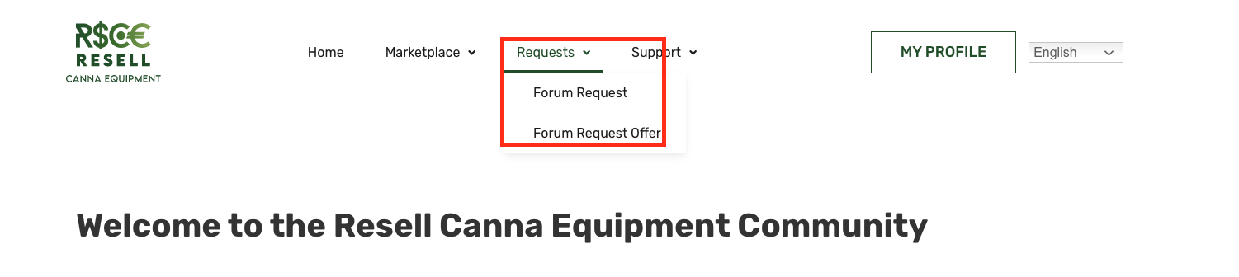

1. When navigating in the page “Product Requests” (currently called “Forum Request Offer”), we need to Add a button called “Create New Product Request” that will be redirecting the user to the page currently called “Forum Request”, allowing them to post a Product Request.

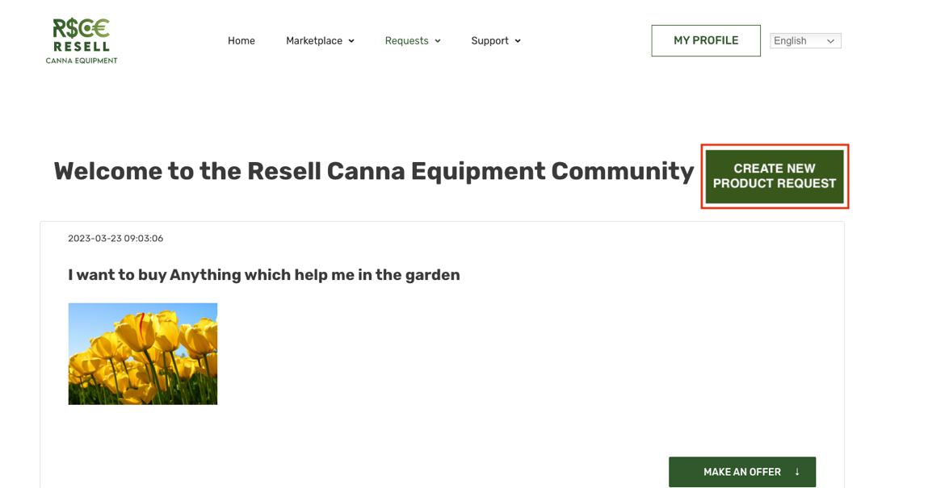

FLOW:

