Milestone

October 4, 2023

I have attached all documents; at the bottom of every task is the document associated with that task. Take a look at the screen shots and pictures.

**1)Register**

* Separate Branch number and intuition # so there are two different sections.
* Change the header to “Register Here”

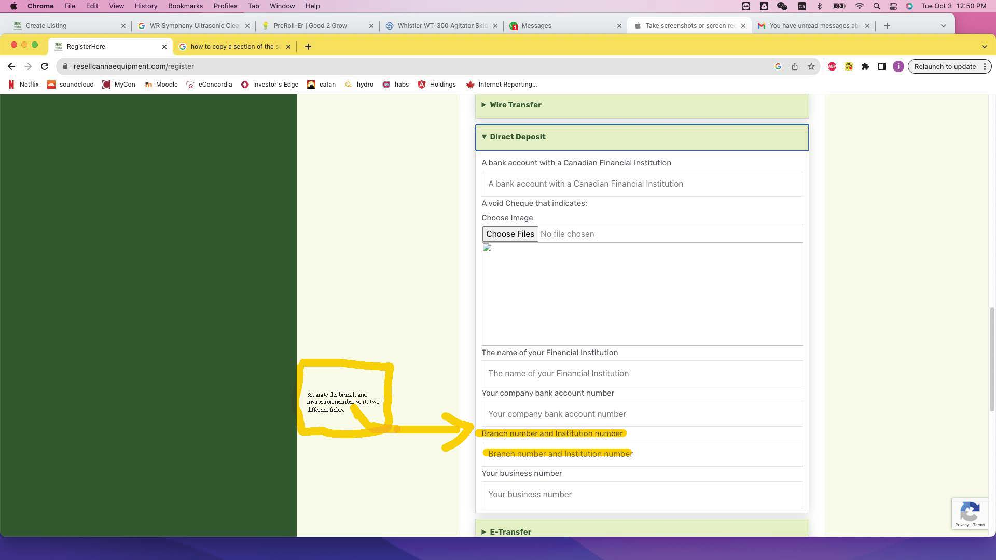

**2)Create Listing Page**

* Choose shipping method should have disclaimer “Items must be palatized” below it.
* Shipping weight (gross weight) add space between Weight and (gross weight).
* Change state to “State/ Province”

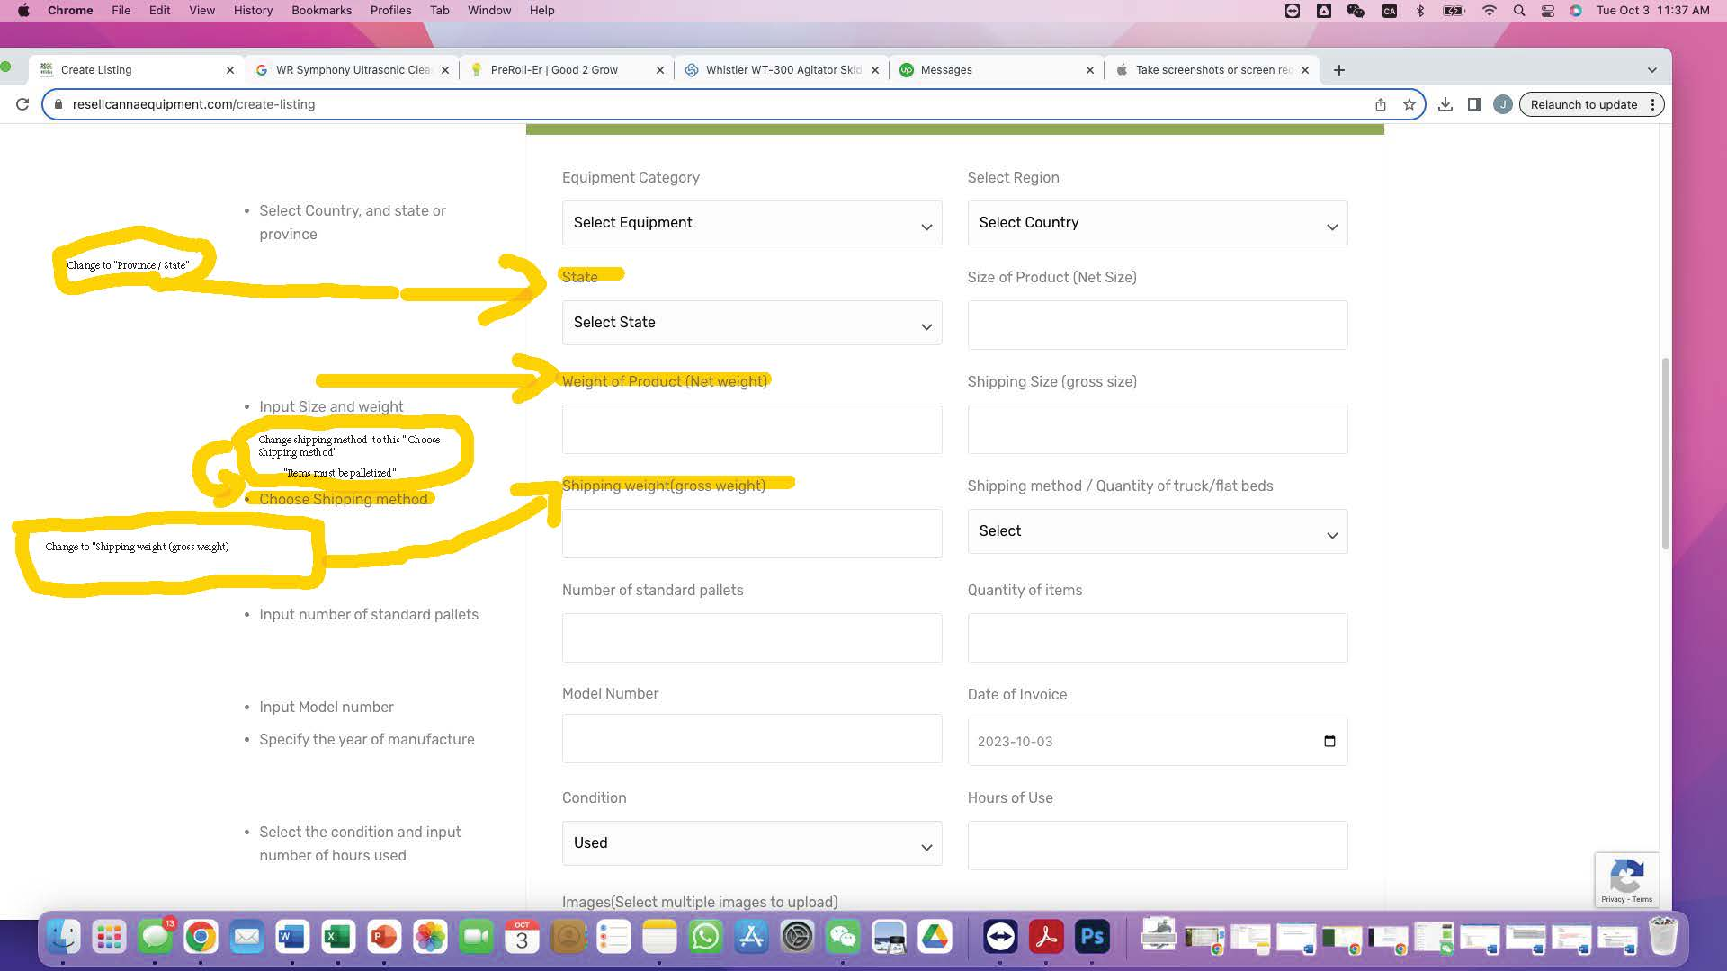

**3)Listing**

* When a client uploads a document to the site…. There should be location on each product page where anyone can access the pdf so they can see it for themselves for example.
* Right next to the send offer there should be a drop down where anyone can download the documents that the clients have uploaded for their products. If you look at the second link they have a drop down menu where you can download pdfs and pictures of the equipment.

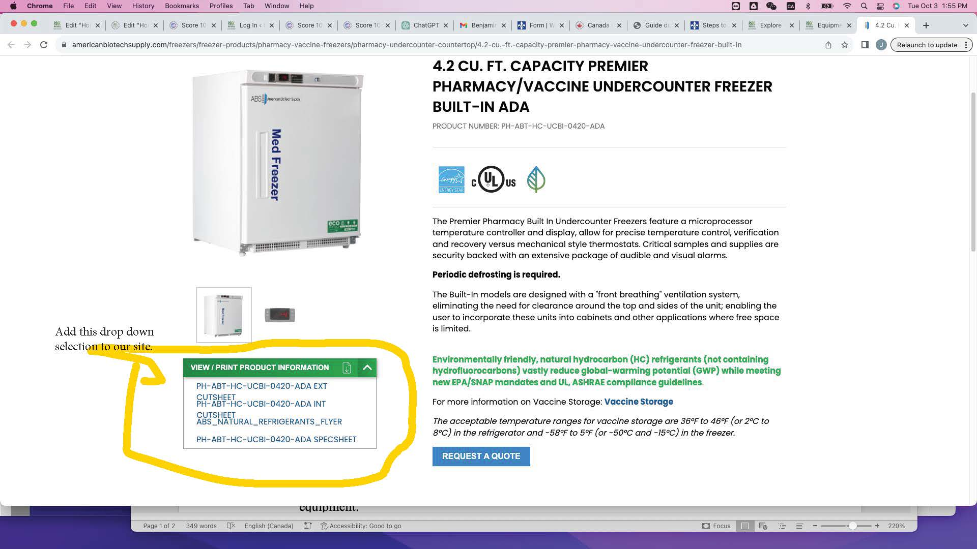

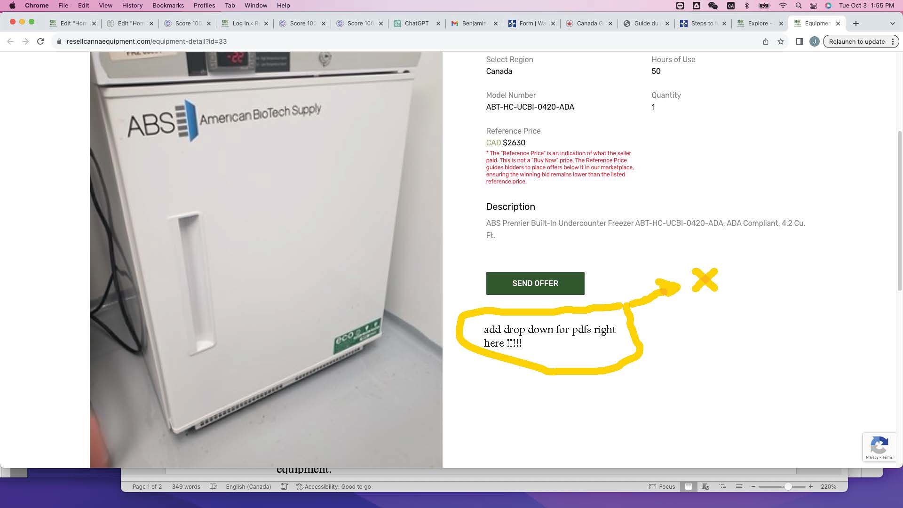

**4)Explore Search bar:**

* I have noticed a bug in the system when you search up products that we don’t have it. The page freezes than refreshes. The search bar should just bring up no search’s not refreshing the page like a glitch………… if you have any question, please let me know.

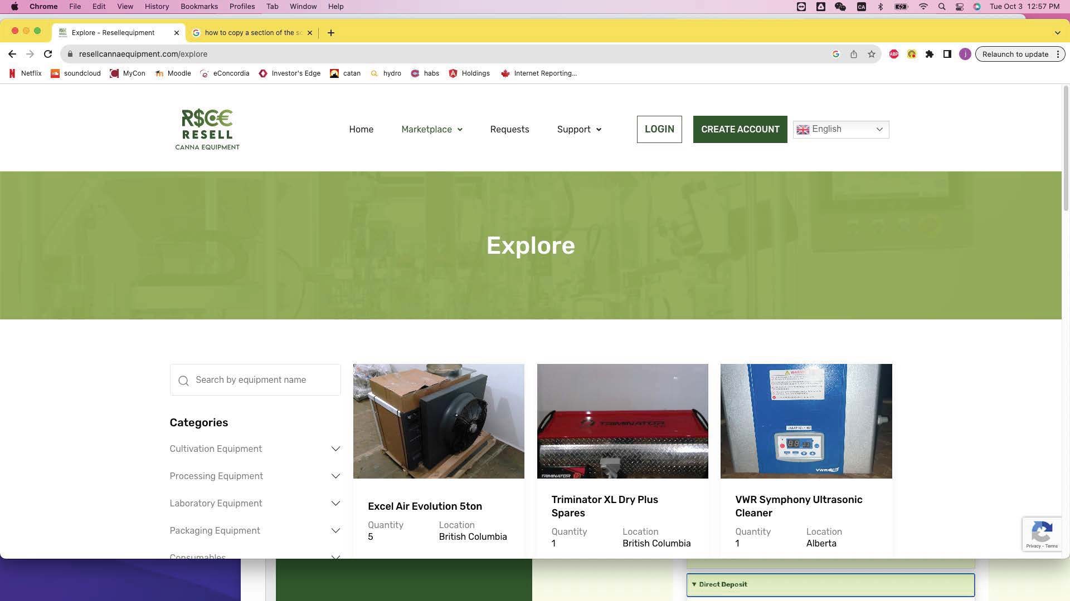

**5) Home Page**

* On the home page we have three images (whistler tech Wt-300), (Mobius M108s Trimmer) and a (preroll-er 200). Change all 3 photos for the new one that I have linked below.
* You need to change the price for the (whistler tech WT-300) ….. Switch the Retail price from $315,000 to $335,000.

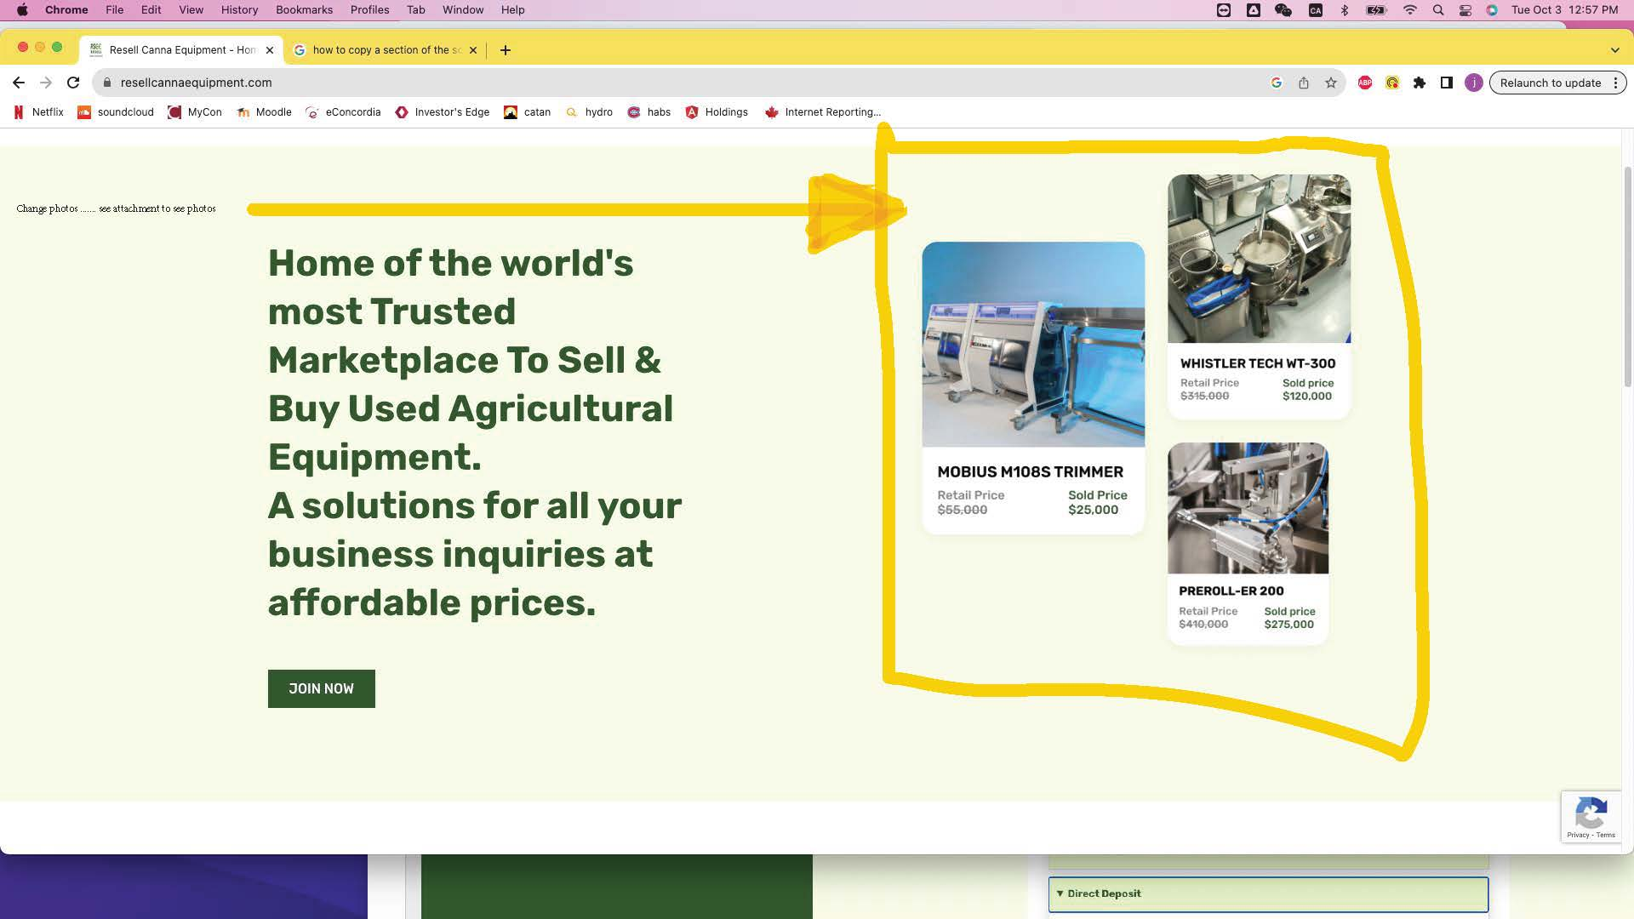

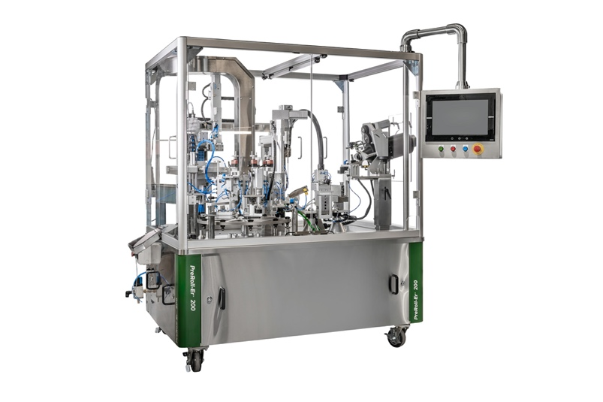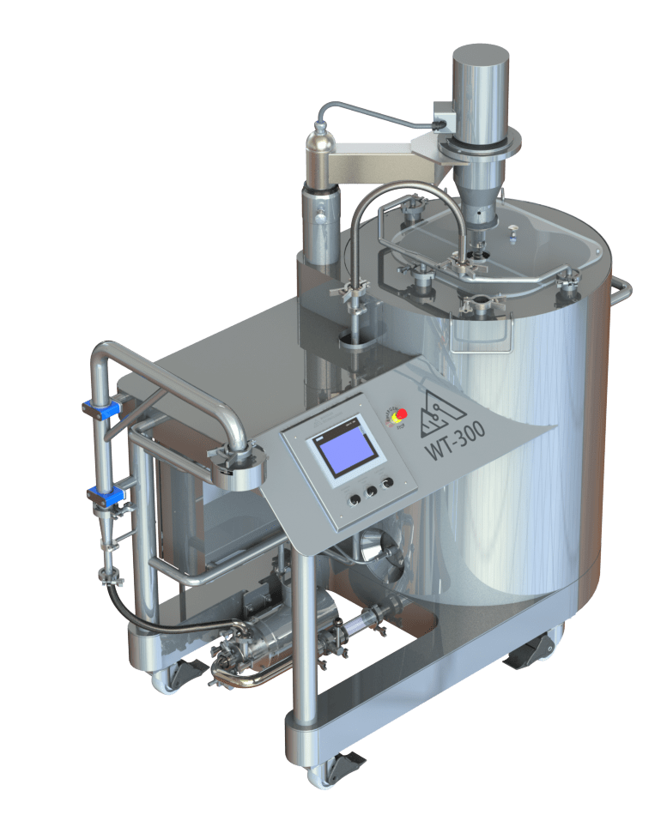

Preroll-er 200

Whistler tech WT-300

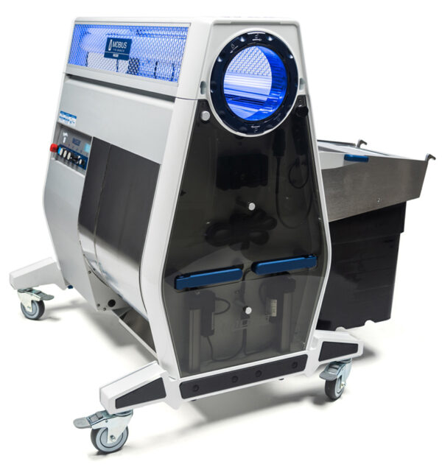

Mobius M108s Trimmer

**6) Backend**

I need access to the explore page, equipment detail, dashboard, and requests so I can work on their SEO’s. As well we need to change the names of “Home fri 2” and “home old” to “Friday 2” and “October Old”.