model off of this site: ethoslife.com. There will be 7-8 pages total initially. Possible pages would be:-
1) Home: Static text page with images.
2) About us: Static text page with images
3) How it works: Static text page with images
4) Why Us: Static text page with images
5) Check my Price -- It takes user to some other url to fill the form so what we need to do about this?
6) Terms life insurance: static page with text and images
7) FAQ -- Can it be added in the same page or we need to same url structure?
8) Privacy: Static text page
9) Terms of Use: Static text page Kindly let me know your thoughts on this so I can provide a ballpark estimate.

Dundas Life Website Plan

Page TItle: Dundas Life | Life Planning
Description: Dundas Life is a planning firm for all of life’s financial needs. Be ready for whatever life brings

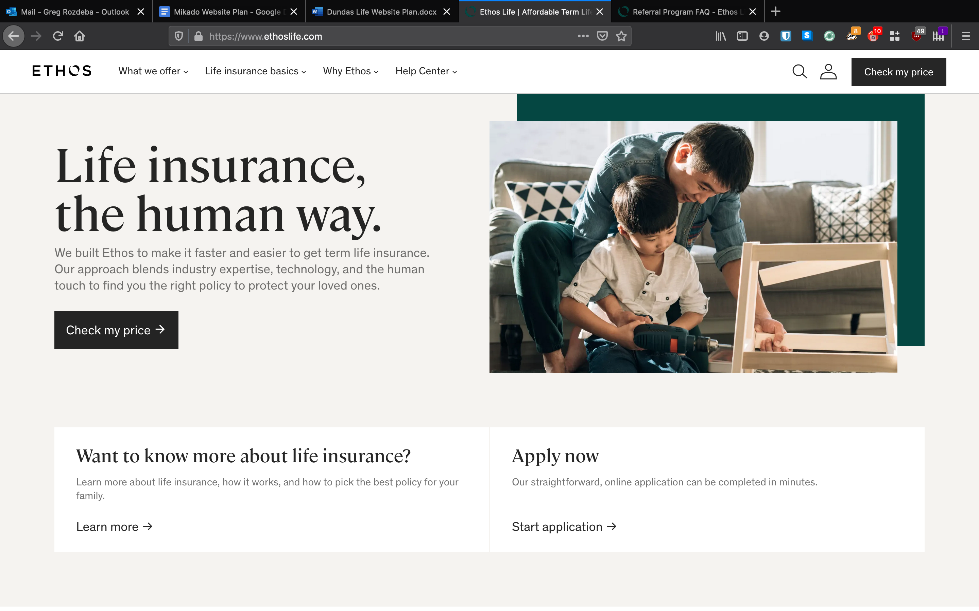
-Change “Life insurance the right way” to The right insurance.
Dundas Life provides Canadians with the best life insurance for their situation. Our technology with best in class industry professionals will find the right policy for you and your family

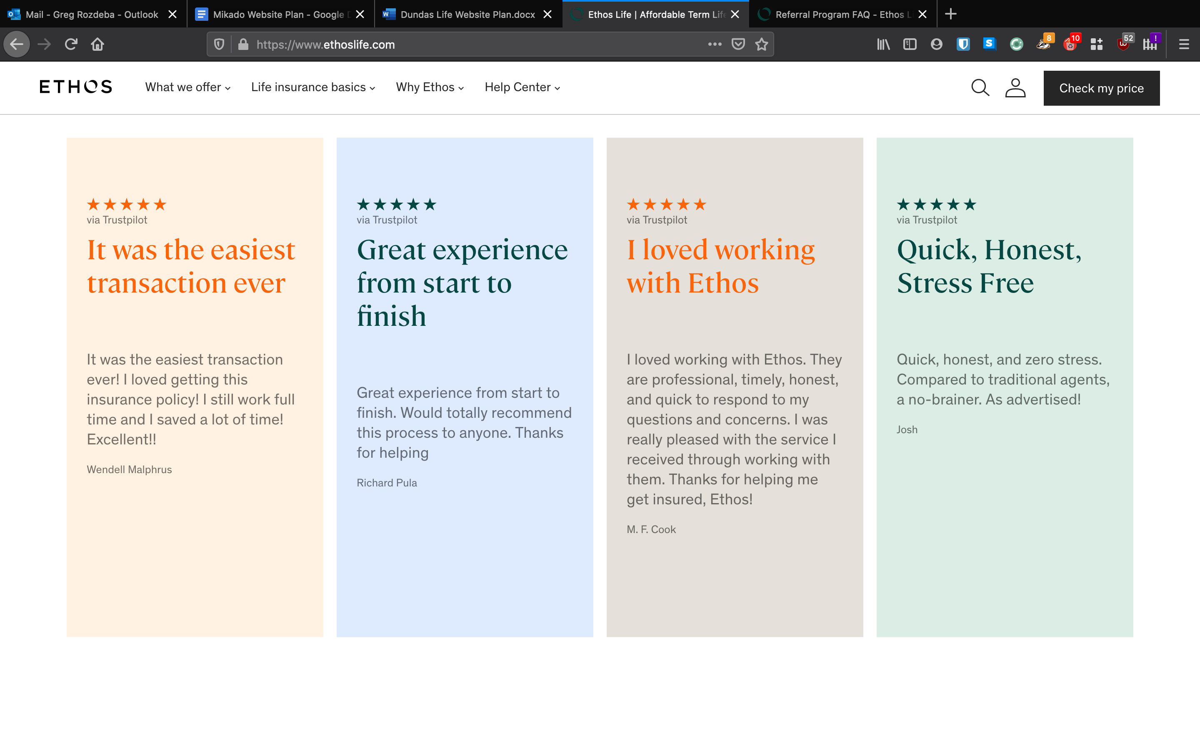
-(Steve) - do you have any existing clients that can give a glowing review?

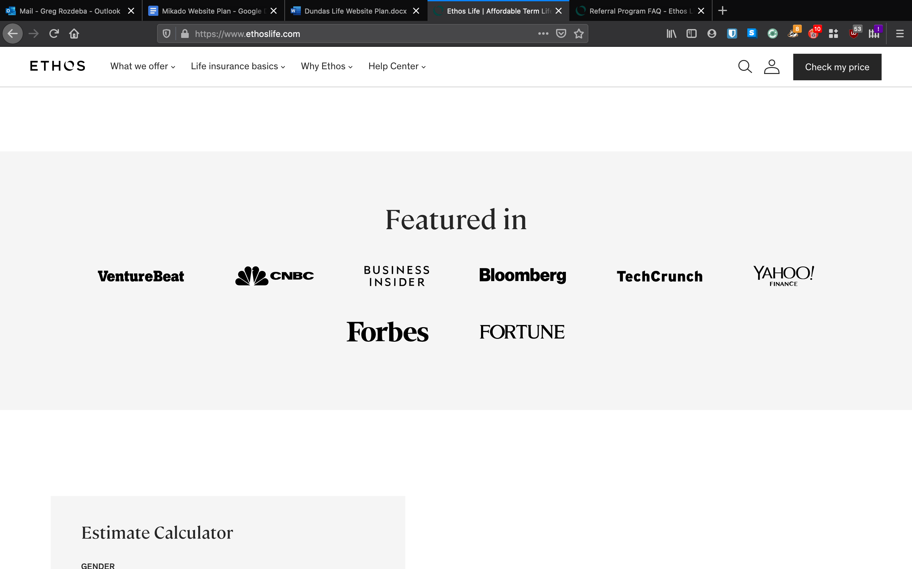

-Instead of featured in, we change it to Partnered with
Canada Life, Sun Life, RBC, BMO, Manulife
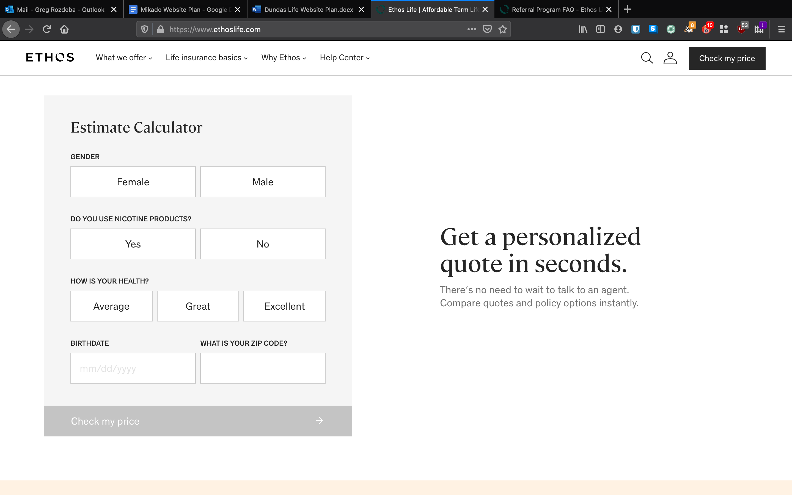
Same calculator but include Name, phone and email before gender
Change zip code to postal code
- “The right quote, quickly” Our intelligent quoting platform works without agent to deliver the right solution straight to your inbox
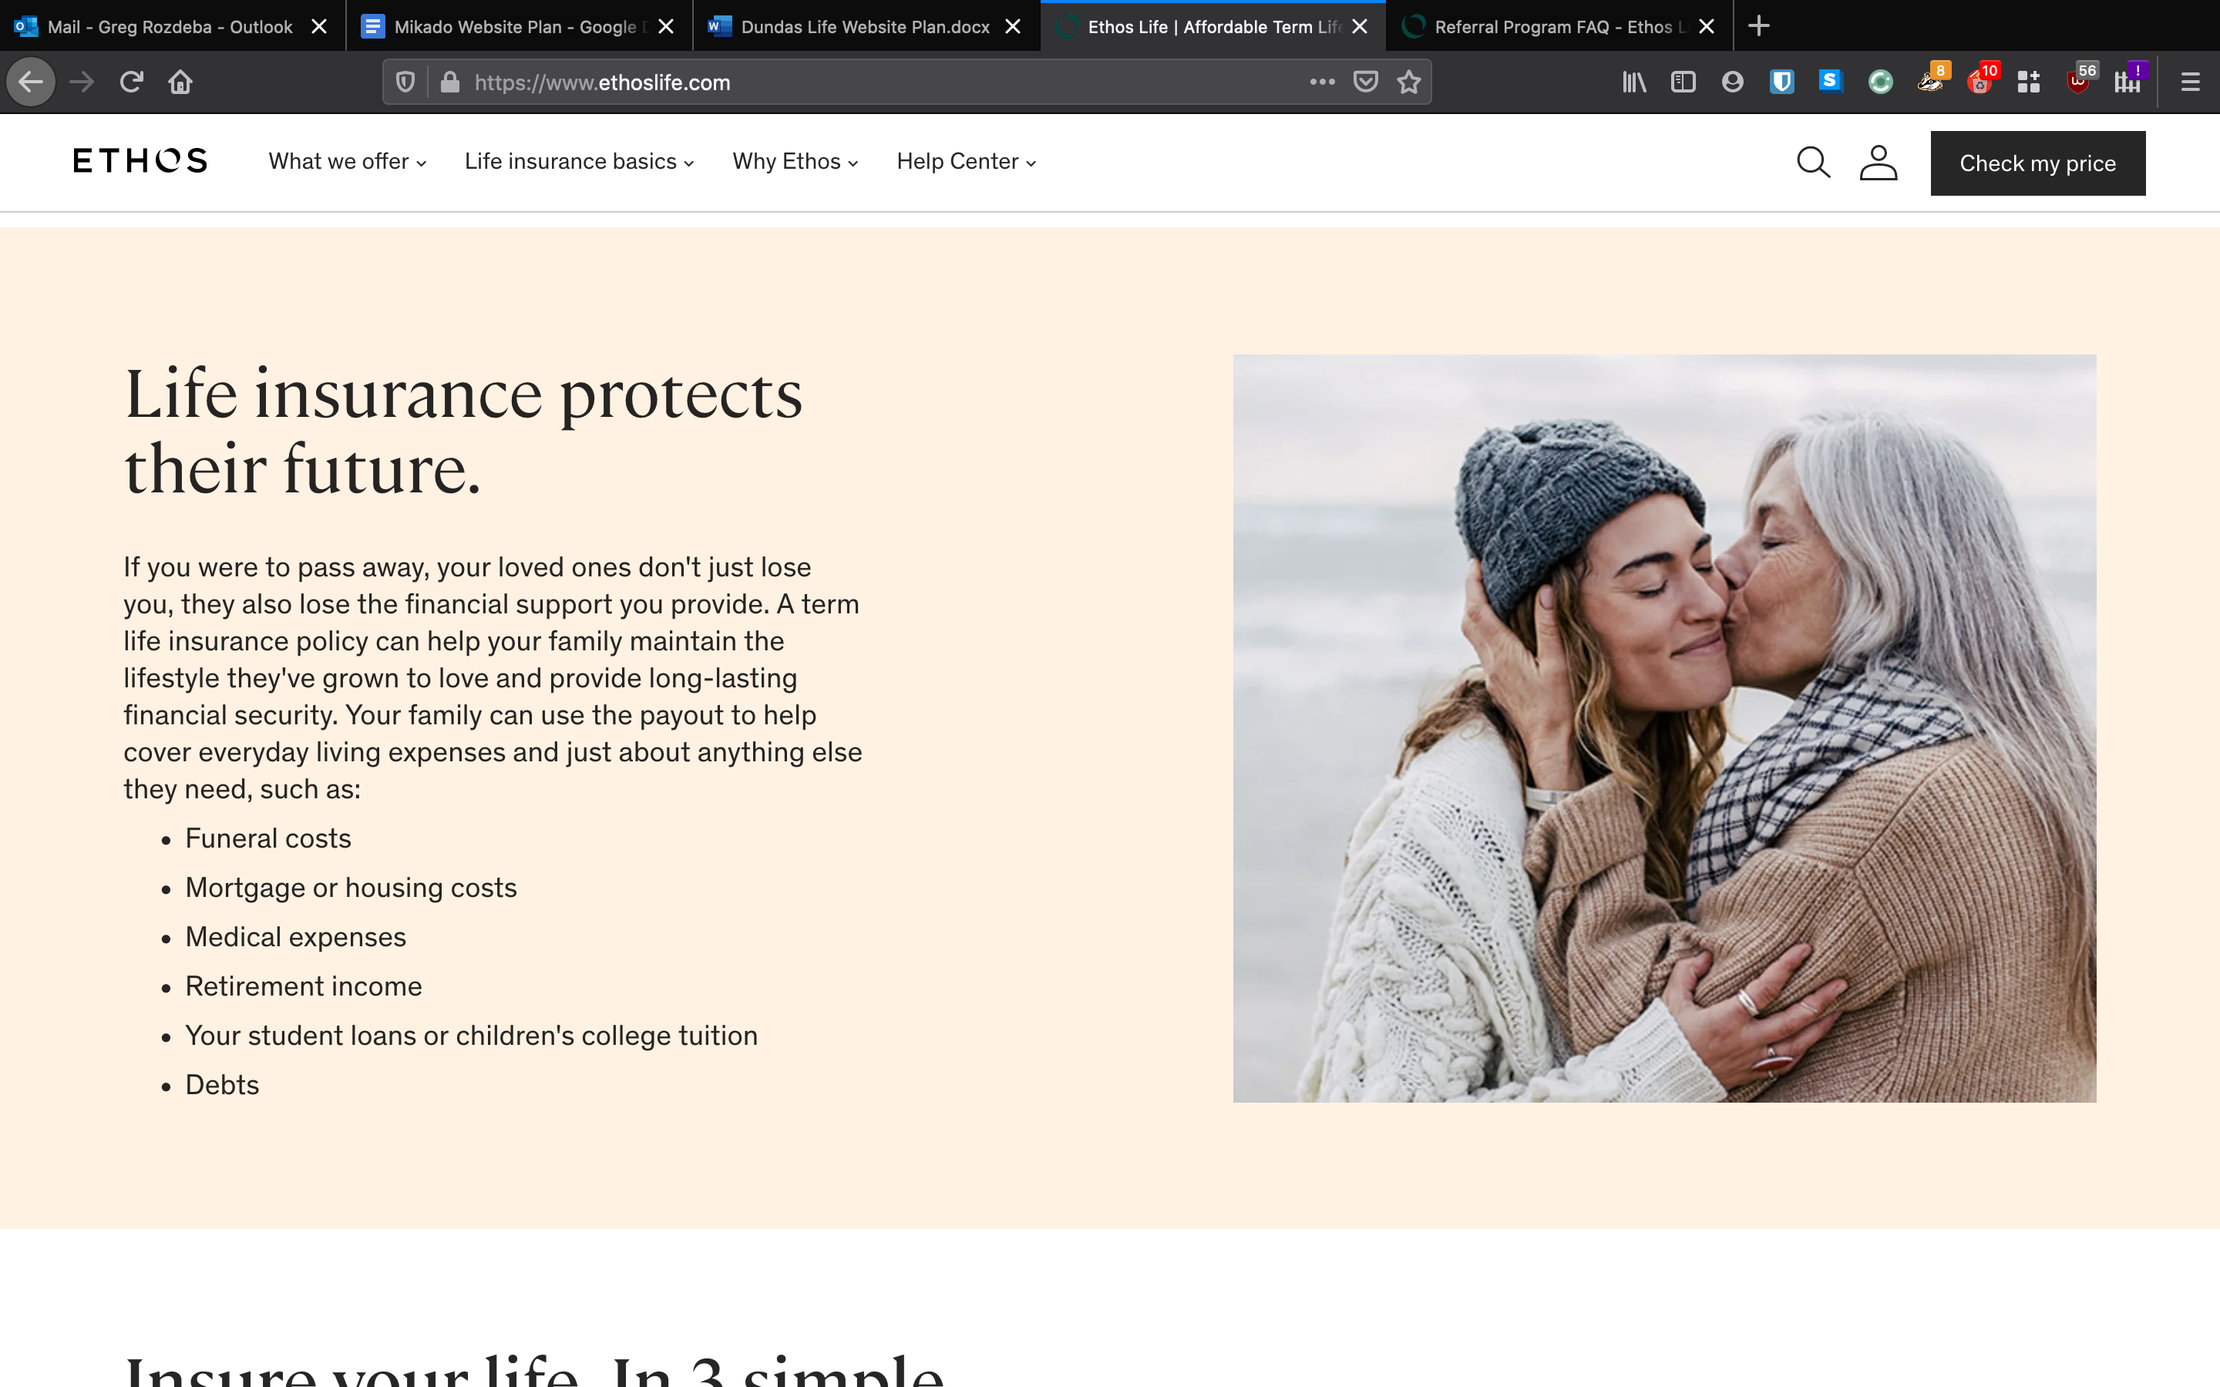
Life insurance builds resilience

If you passed away, would your family have to make very difficult decision their financial future? A basic insurance policy can ensure that you have enough capital to pay off your mortgage and provide a financial future for your family in case of life's unfortunate events. Insurance can help your family cover costs such as:

Retirement
Medical Costs
Children’s College Education
Cover Debts
Mortgage expenses

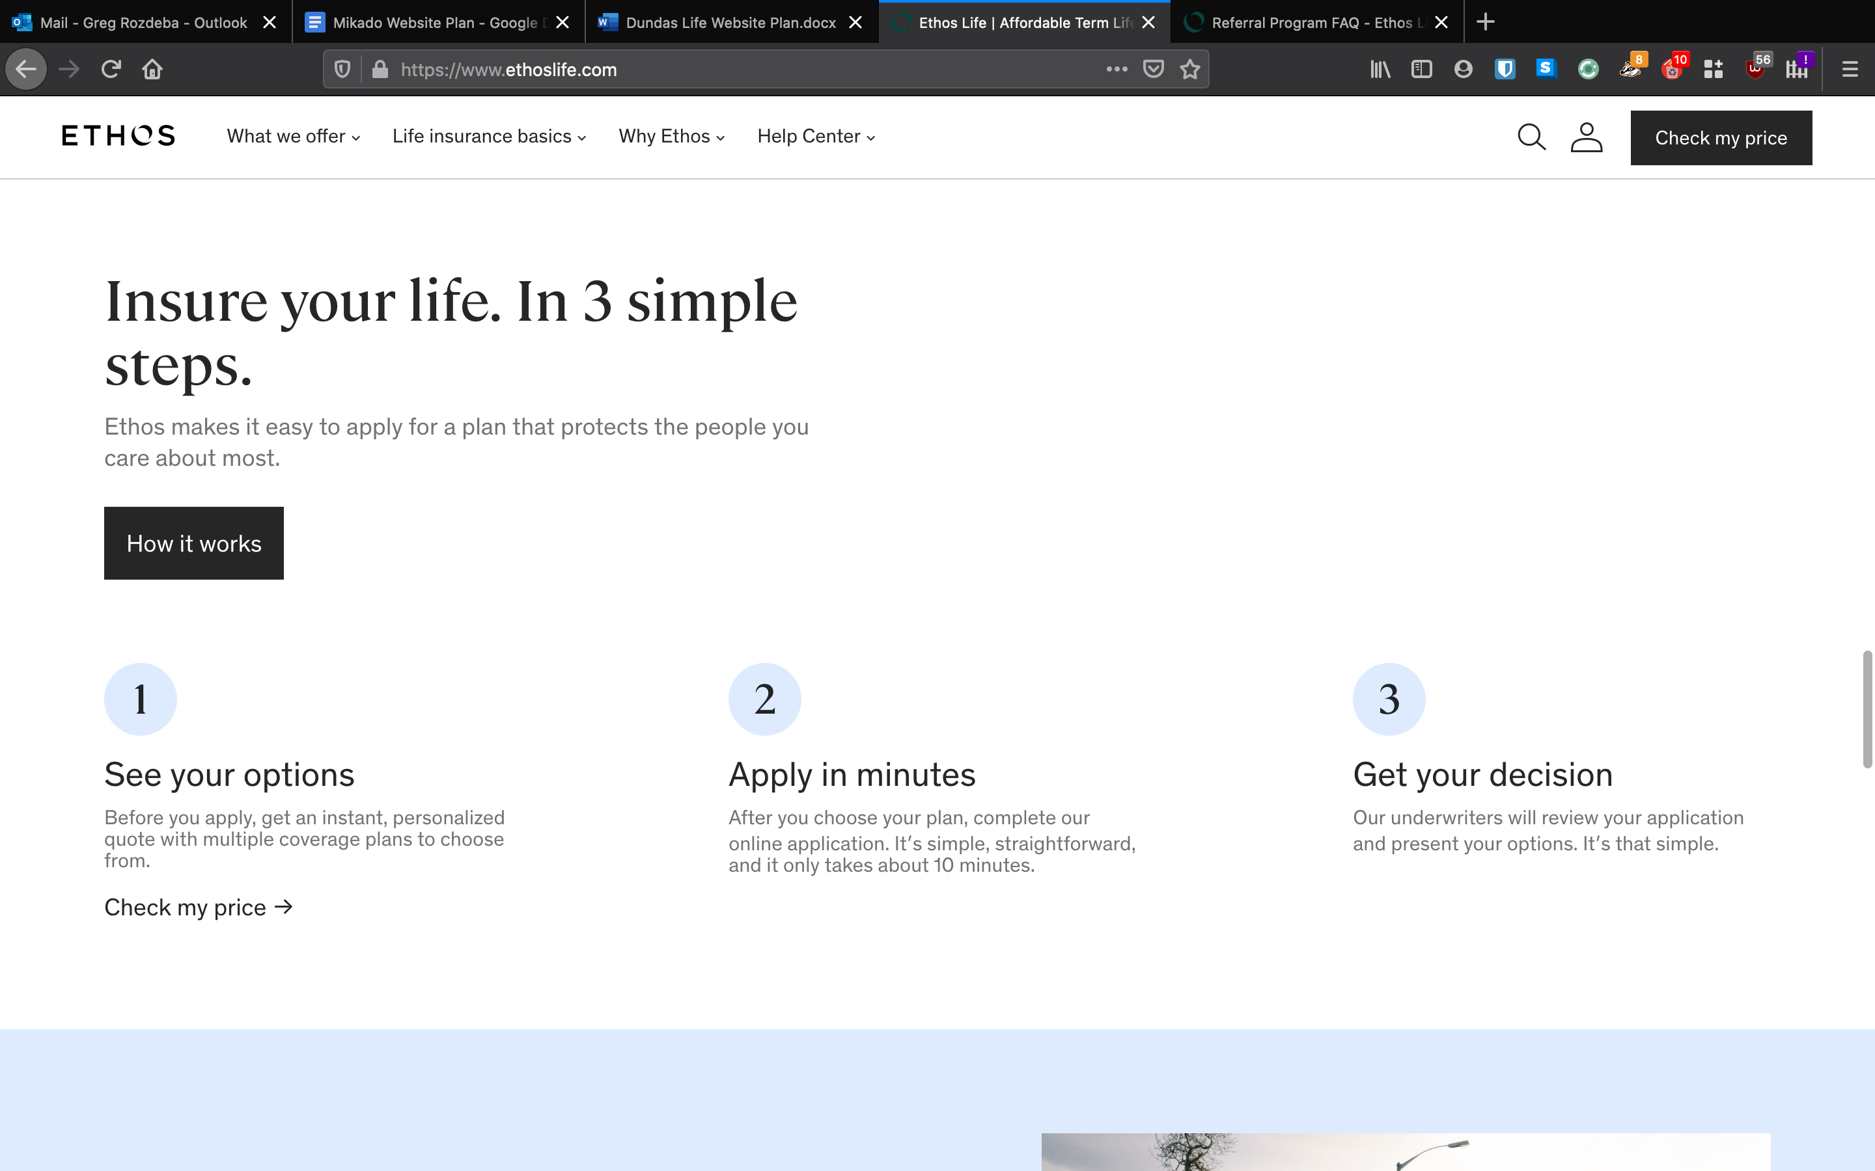
Protect yourself
We strive to make the insurance buying process as simple as possible with available help
1) Submit your need – are you getting a house? Starting a family? Let us know
2) Number crunching – our platform will provide you with a quote to a valid email. If you have questions, or a more complicated need, we’re need to help by phone, chat or video call
3) Proposal – we will provide you with a custom proposal that covers what’s most important to you

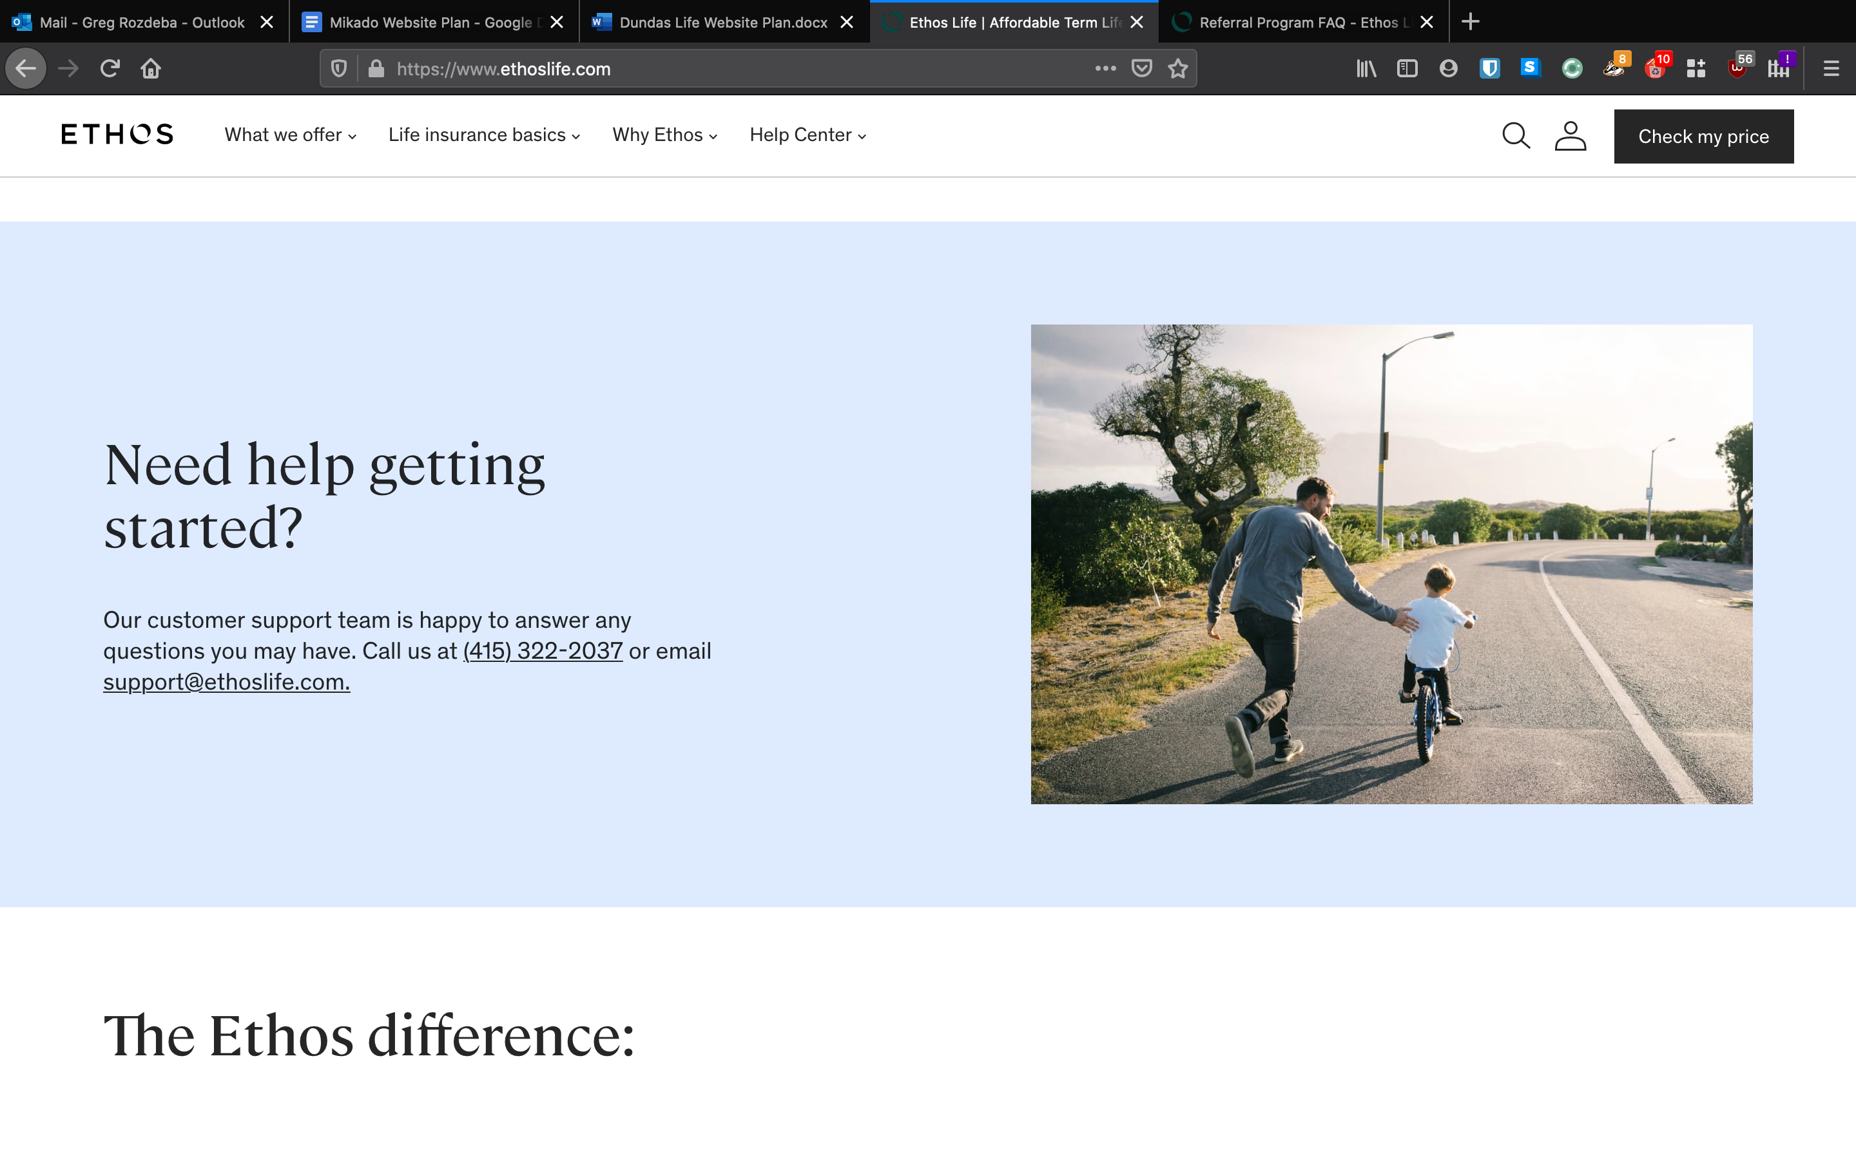

Where to start? - Shoot us a line in the chat below

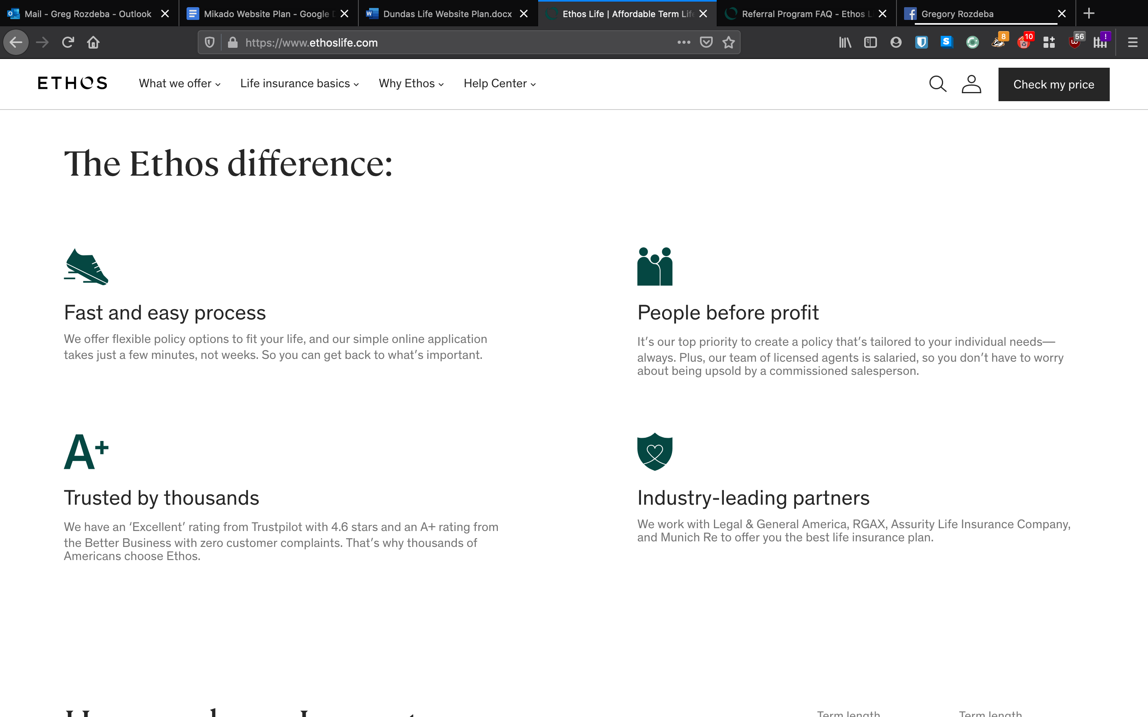
Keep it simple – insurance is complicated, that’s why we’re here. We take the time to explain every step along the way

The right solution – everyone has different needs, we will work with you to find the the right fit

Earning your trust –planning for life’s contingencies is a sensitive topic. We approach every conversation with understanding and compassion

The best partner – we work with all of Canada’s major insurance carriers but will only position the product that is right for you

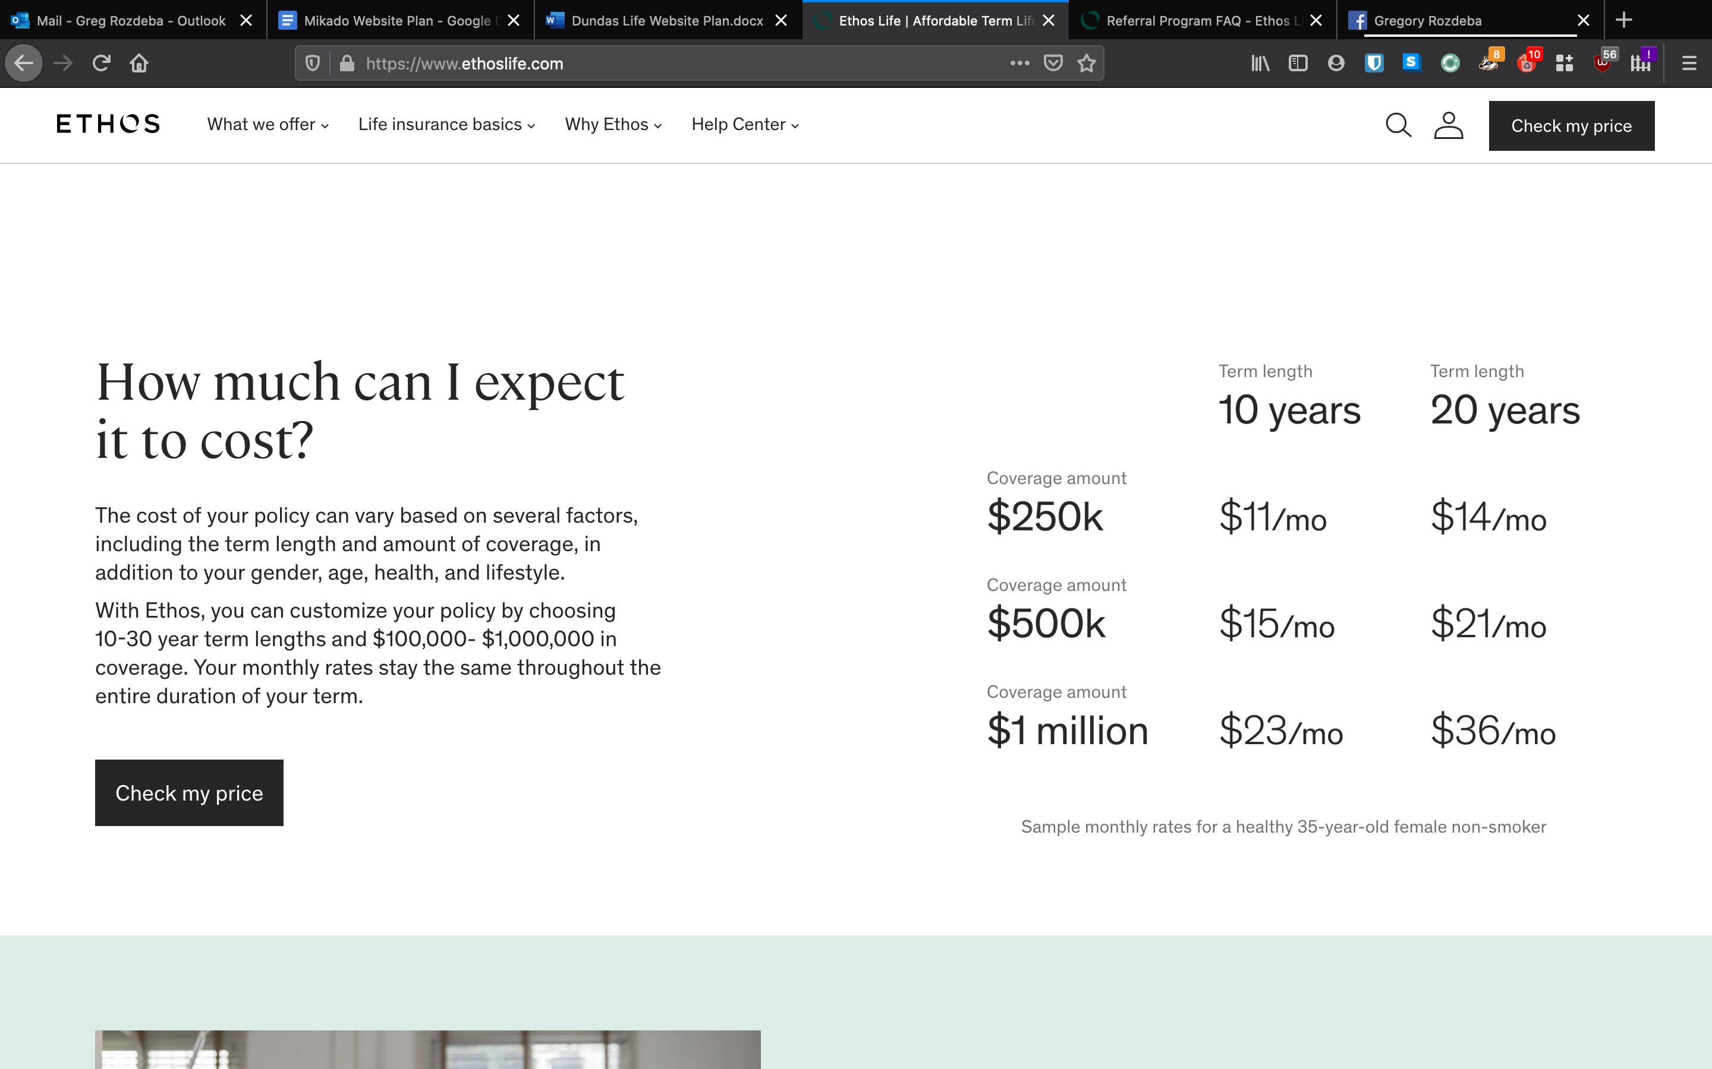
How expensive is insurance?

There are multiple factors that go into determining the cost of a policy including health, gender age etc.
Basic policies that may provide an adequate amount of coverage can be relatively inexpensive.

***CONTACT US*** (when a prospect clicks on this section, they get taken to the simple intake form)

Blog to write with Steve
Life insurance 101
Wondering where to start? We’ve broken down the essentials for you.
What are the main types of life insurance and how do they work?
Choosing your beneficiary
Is my life insurance through work enough?
What is underwriting and how long does it take?
What if I don't work?

