**REQUIREMENTS -:**

The client has a WordPress sitethat offers lawn care services to the customers.

Link for the site-: <https://tegritylawn.com/>

Now the client is looking to develop a custom plugin that will allow users to enter their location, area of the lawn and select services packages.

Note-: the plugin will be productized in future.

The following are the figma designs for the lawn care booking plugin.

<https://www.figma.com/proto/Gf7MpUn7dWSYhUK2PPlvUU/Tegrity-Lawn-Service?node-id=230-296&scaling=min-zoom&page-id=32%3A2>

We need to implement this on client’s store.

On homepage the **“Get quote now”** form will be visible.



**The flow of the plugin will be -:**

1. The user will enter the name and email address.

2. Next, the customer will enter their address.

Note-: The client offers services to the following zip codes. The plugin will check for the zip code and if the zip code is not found then a sorry message will be displayed.

[89439, 89523, 89511, 89519, 89509, 89503, 89521, 89502, 89434, 89436, 89433, 89431, 89512, 89557, 89501]

3. Then the customer will enter their lawn size.

4. Then the customer will select whether they have bushes and if yes then they will enter the number.

5. Next the customer will select whether they have overgrown mow or not.

6. Once the services are selected, then the plugin will display the packages to the customers.

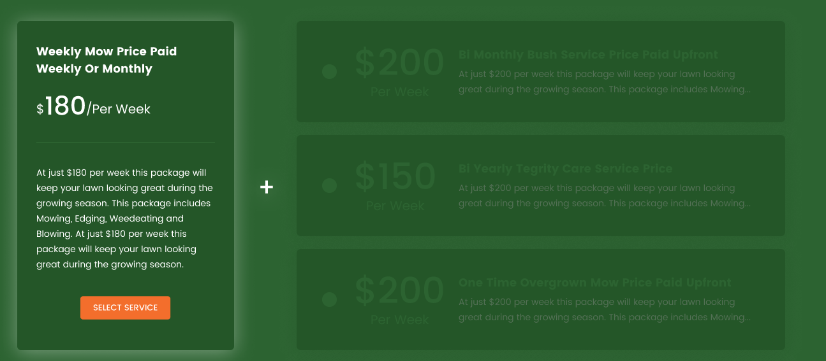

The first package will be highlighted and all other packages will not be available until the user selects first.

Once the user selects first package, then all other packages will be available for selection.

The user will select their desired package and click on “find spot on schedule”

The algorithm will work and find the schedule accordingly.

The summary of the order with payment information will be displayed.

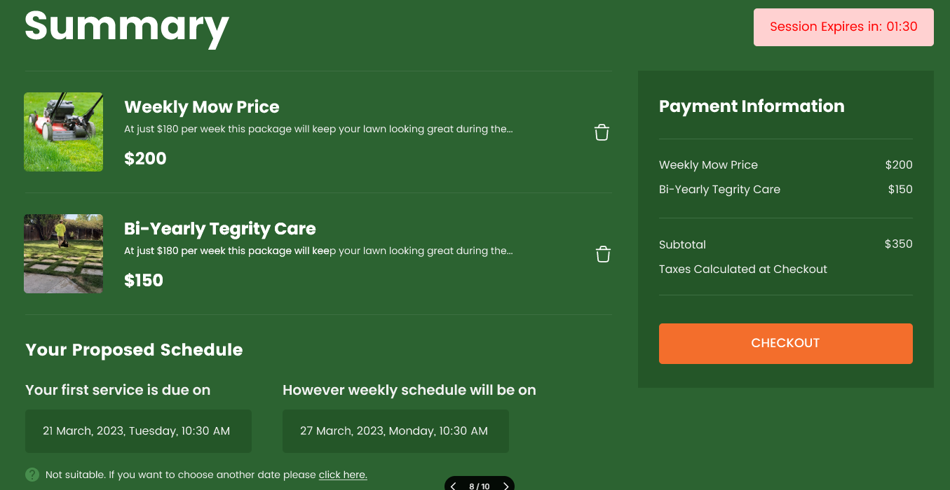

7. The user can check out if they are comfortable with the schedule.

8. If they want to find another schedule, the algorithm will show another schedule.

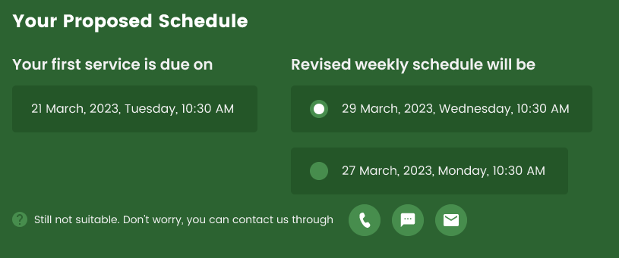

9. If still the schedule is not suitable the user can contact through mobile, SMS and mail.

10. If the schedule is suitable, the user will process the payment. On successful processing the schedule will be booked on the calendar.

**Admin panel-:**

* There will be an admin panel for admin to manage their schedules.
* We will be integrating calendar in the admin panel.
* The admin will setup their availability and their existing schedule through the admin panel.
* The schedule will be booked on calendar once the payment is processes. The confirmation will be sent through the website.

**Other tasks-:**

1. We will be integrating the Stripe payment gateway

2. We will be Integrating HubSpot with the site. So when a new user creates the order details will be saved in HubSpot.

**Scheduling algorithm-:**

* I have attached the document explaining the scheduling algorithm.