**The link has Giggly. We need to change it to Trulu**

<https://development.brstdev.com/giggly/#>

**Error in Google Login:**

**Notice**: Trying to get property 'ID' of non-object in **/home/developement/public_html/giggly/wp-content/plugins/miniorange-login-openid/mo-openid-social-login-functions.php** on line **226**  
  
**Notice**: Trying to get property 'user_login' of non-object in **/home/developement/public_html/giggly/wp-content/plugins/miniorange-login-openid/social_apps/mo_openid_configured_apps_funct.php** on line **269**  
  
**Notice**: Trying to get property 'ID' of non-object in **/home/developement/public_html/giggly/wp-content/plugins/woocommerce/includes/wc-user-functions.php** on line **902**  
  
**Notice**: Trying to get property 'ID' of non-object in **/home/developement/public_html/giggly/wp-content/plugins/woocommerce/includes/wc-user-functions.php** on line **903**

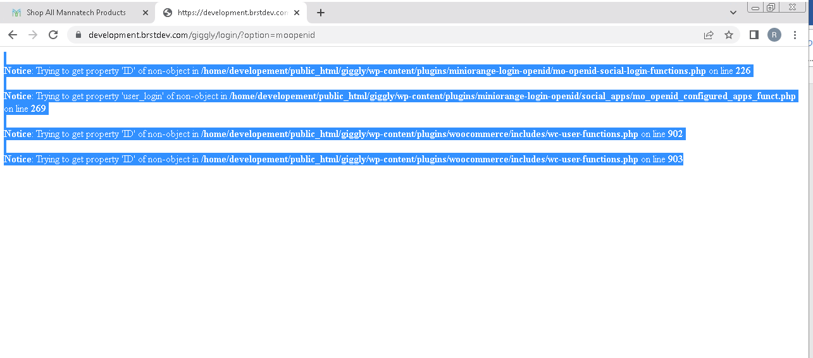

**Create Account Error:**

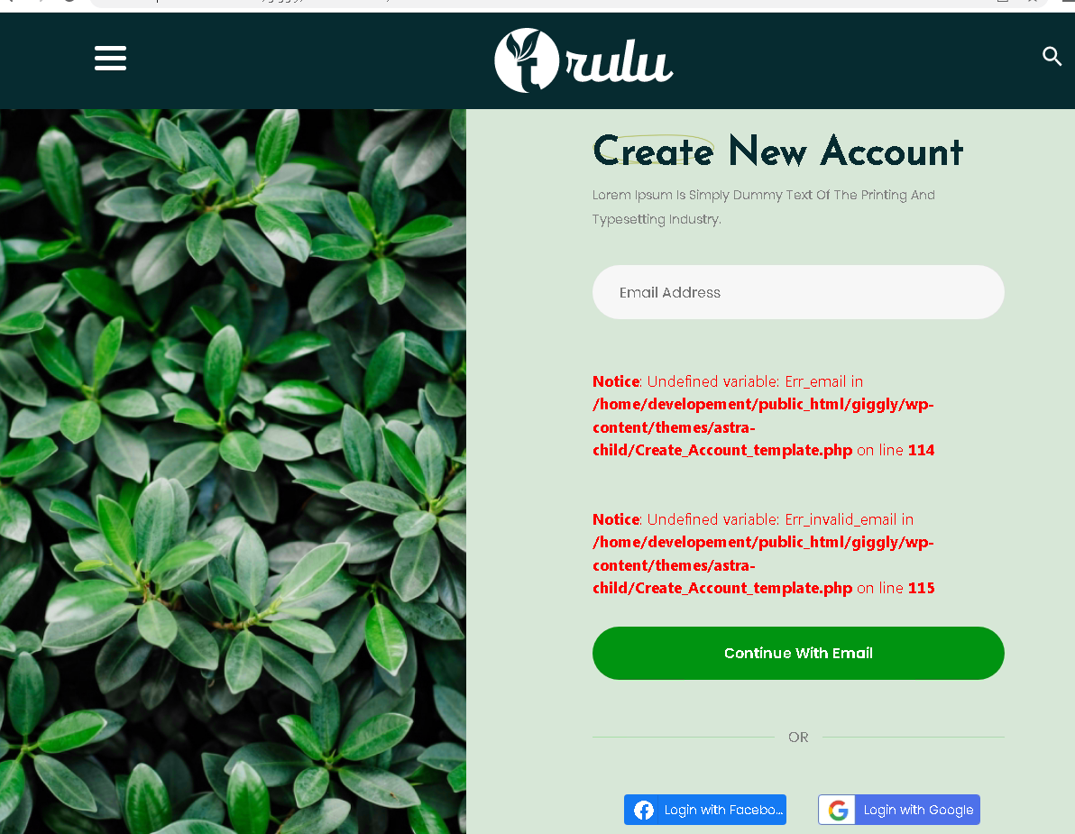

Trying to use Facebook

**Notice**: Trying to get property 'ID' of non-object in **/home/developement/public_html/giggly/wp-content/plugins/miniorange-login-openid/mo-openid-social-login-functions.php** on line **226**  
  
**Notice**: Trying to get property 'user_login' of non-object in **/home/developement/public_html/giggly/wp-content/plugins/miniorange-login-openid/social_apps/mo_openid_configured_apps_funct.php** on line **269**  
  
**Notice**: Trying to get property 'ID' of non-object in **/home/developement/public_html/giggly/wp-content/plugins/woocommerce/includes/wc-user-functions.php** on line **902**  
  
**Notice**: Trying to get property 'ID' of non-object in **/home/developement/public_html/giggly/wp-content/plugins/woocommerce/includes/wc-user-functions.php** on line **903**

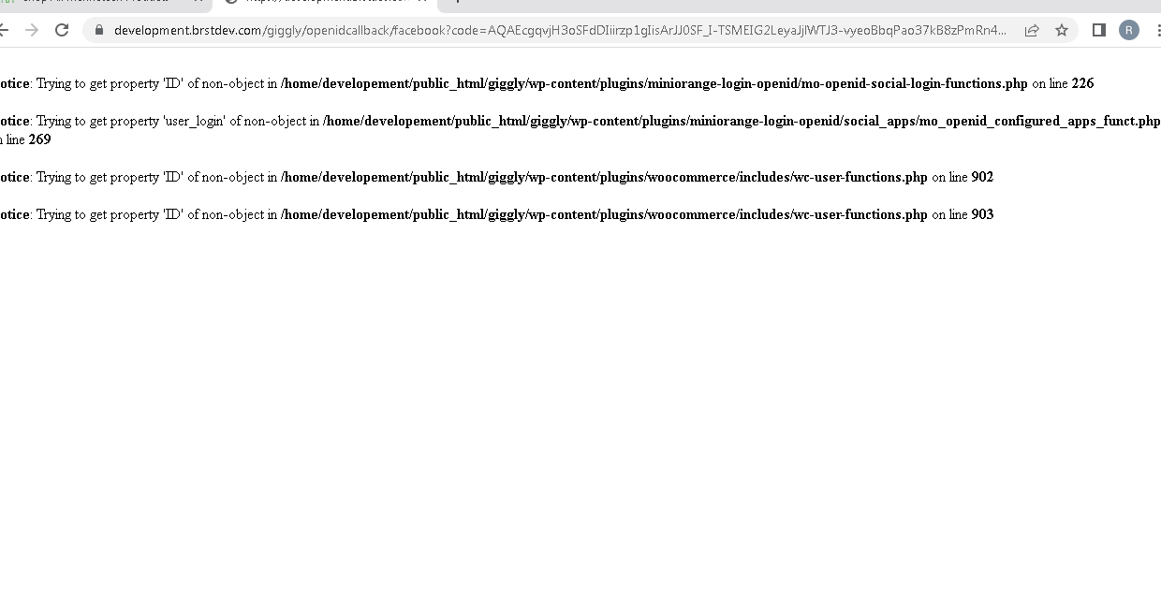

**Shopping :**

[Products – Giggly (brstdev.com)](https://development.brstdev.com/giggly/shop/)

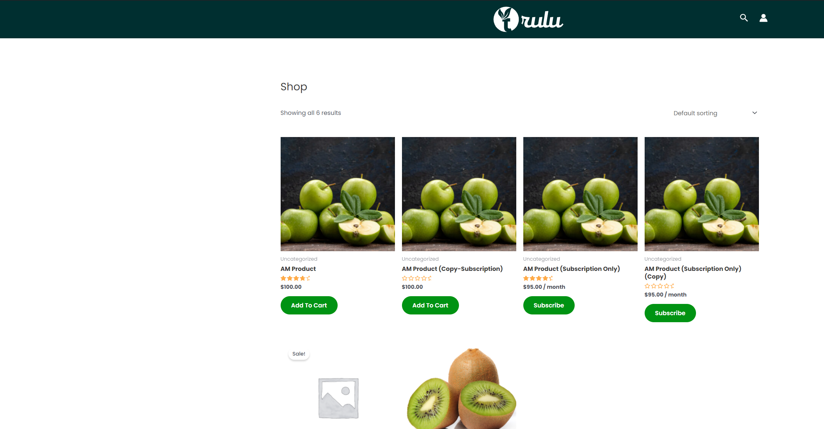

**I cannot tell what is in the cart. A cart icon with count will be good.**

**Do not see any continue or checkout button, so do not know how to check out**

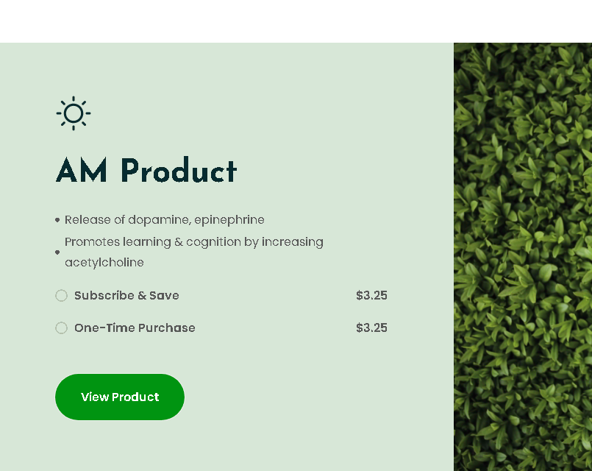

**View product takes to home page, not the product**

**Same with all buttons on home page**

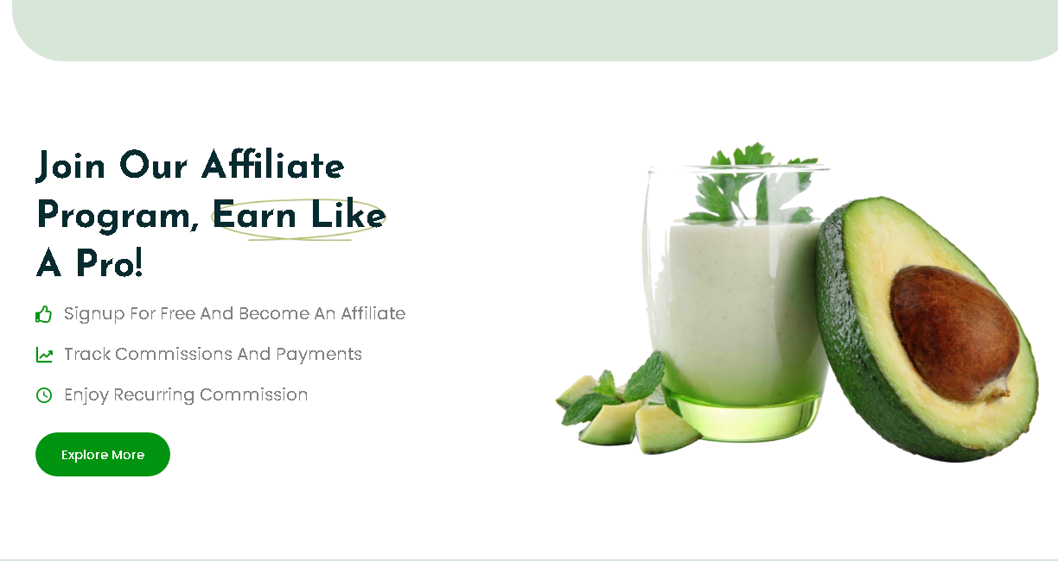

**From the main menu Our Products**